**JUMP MINI PROJECT-2**

**BY AREEN REDDY (2101CS19) &**

**RAGHAVENDRA(2101CS30)**

**AIM:-**

The Aim of this mini project is to see how does this mini game jump work and we have included the steps needed.

**WORKING:-**

We need to write a C code on the game project to determine the lengths,movements,speed etc. we also need to mention the process of total game on how to run we also define the objects dimensions and their movements and speed.

We need to set up our fgpa setup by using the DE1-SoC and make necessary connections with the fgpa board,cpu,computer and a second monitor and give necessary power supply.

First of all we need to download the mini.c(our project code) into the intel fgpa on the computer and connect to the system and then compile and load it on to screen if there are any errors the code might not be compiled so we need to make sure that there are no errors. And after downloading the system and loading the code it should show like this:

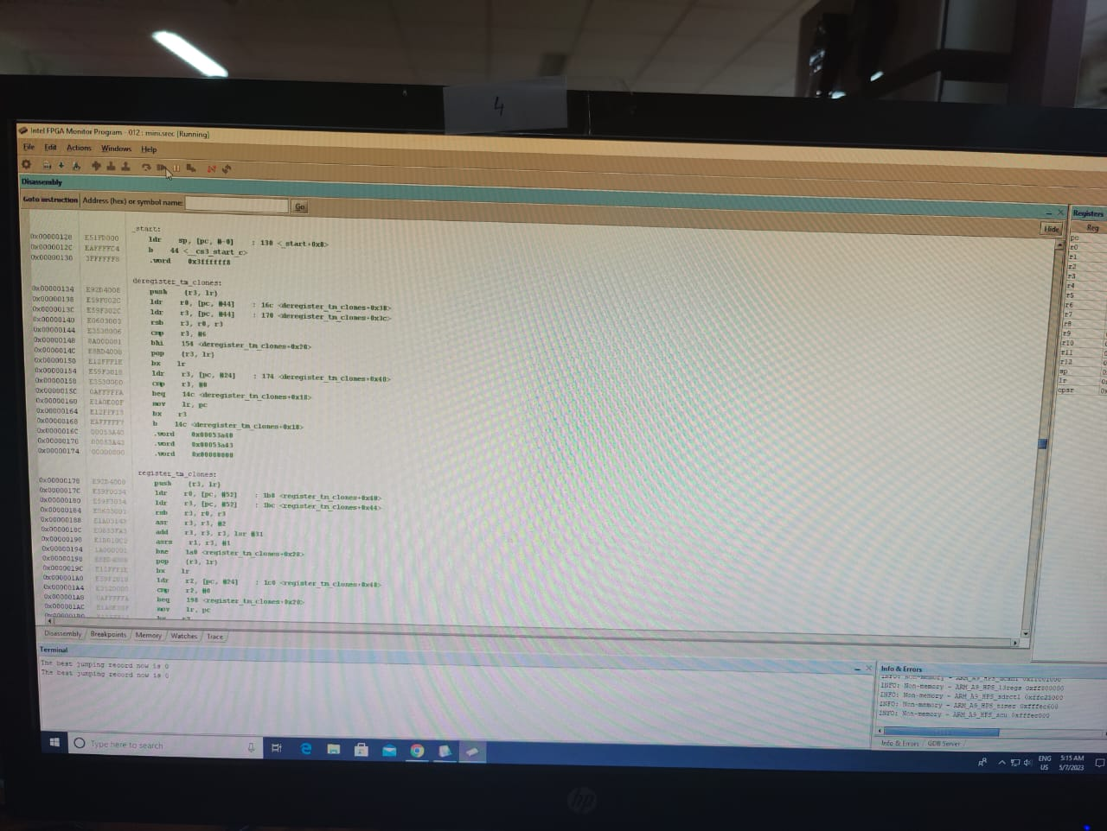

After it shows as the above picture now click on continue on the top options to load the code into the second monitor. We have designed a home page for the game which will be displayed as:

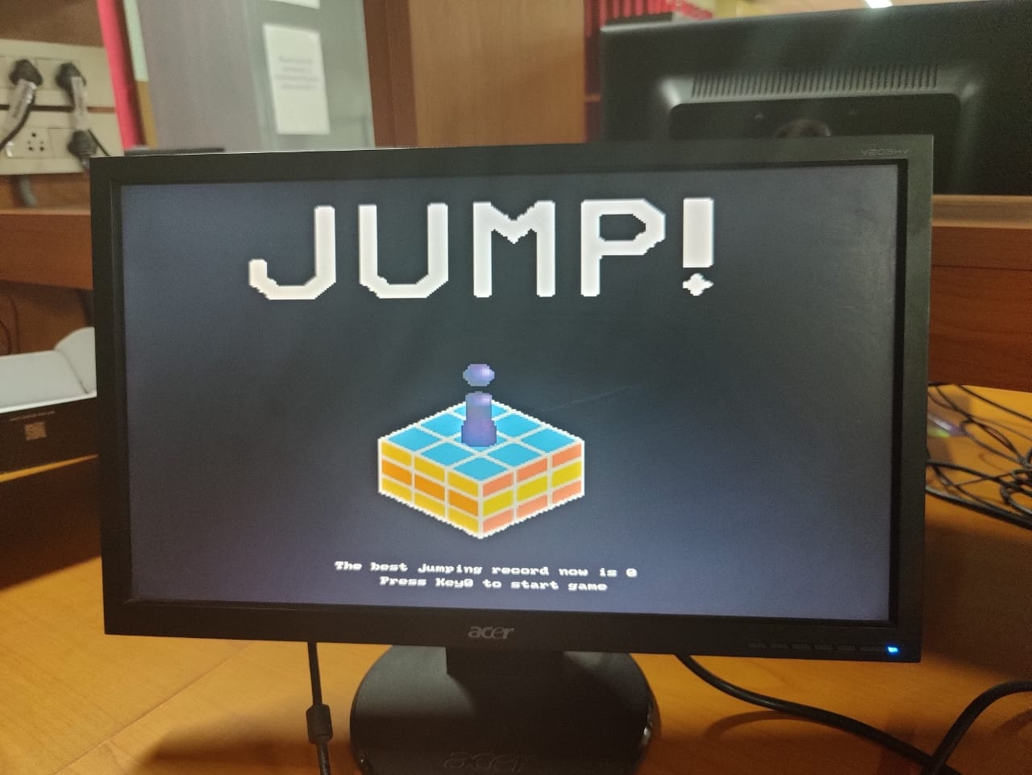

This the welcome page designed by us, as we can see it also displays “press key0 to start the game” we have assigned key0 as only switch to play the game to make it simple.

**How the game works:-**

First we can start the game jump by pressing key0 on the fpga board then the game starts with the object standing on a block and another block appearing at randomn distance from the initial block (we have designed six different blocks including the one in the homepage in this mini game) the monitor displays the intial part of the game after starting it by pressing key0 as follows:

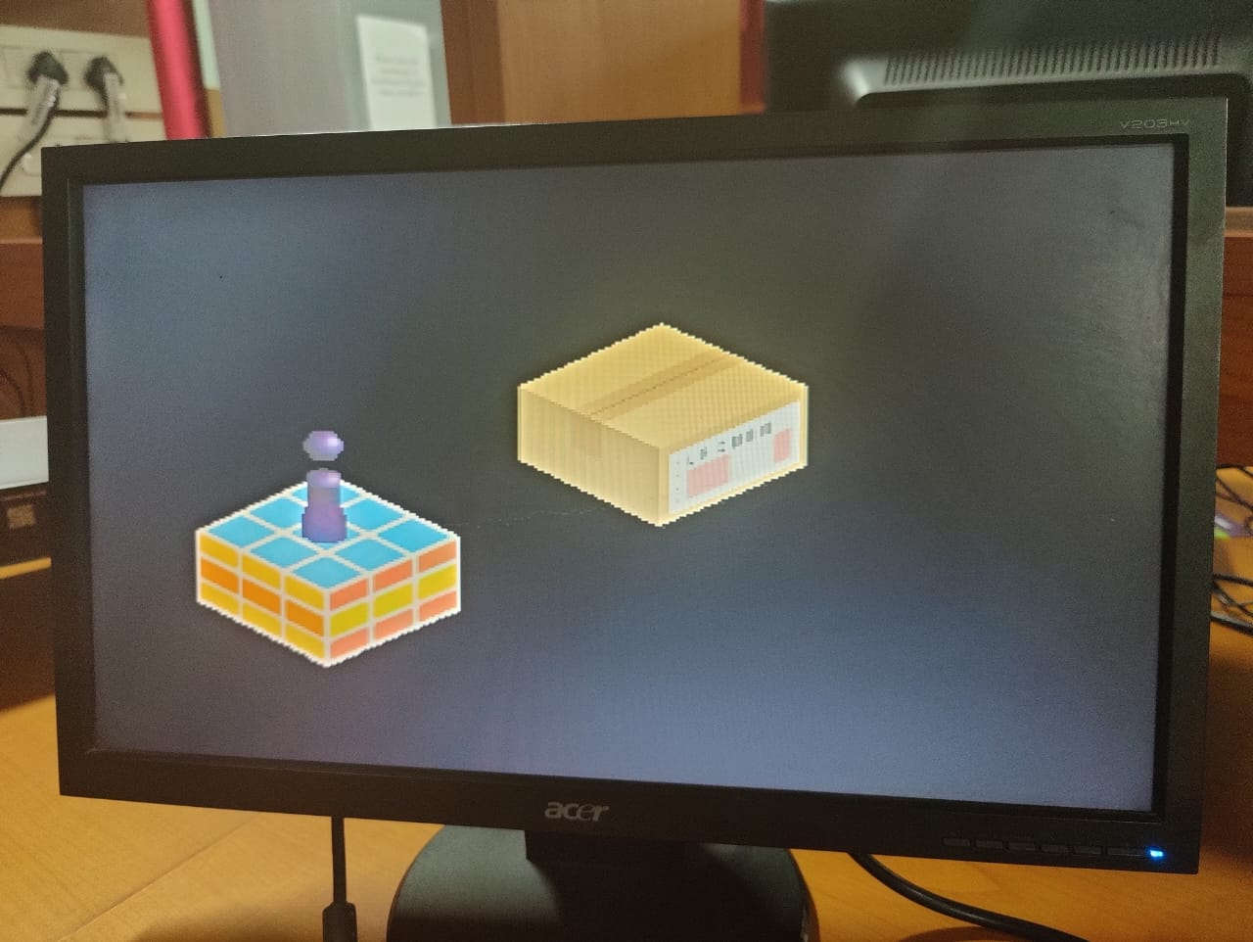

After the game starts as mentioned above you need to jump from one block to another this action can be done by press and hold of key0.Now we have compied the code in the way that the 2 functions of key0 do not conflict with each other and we used key0 to make the game simple

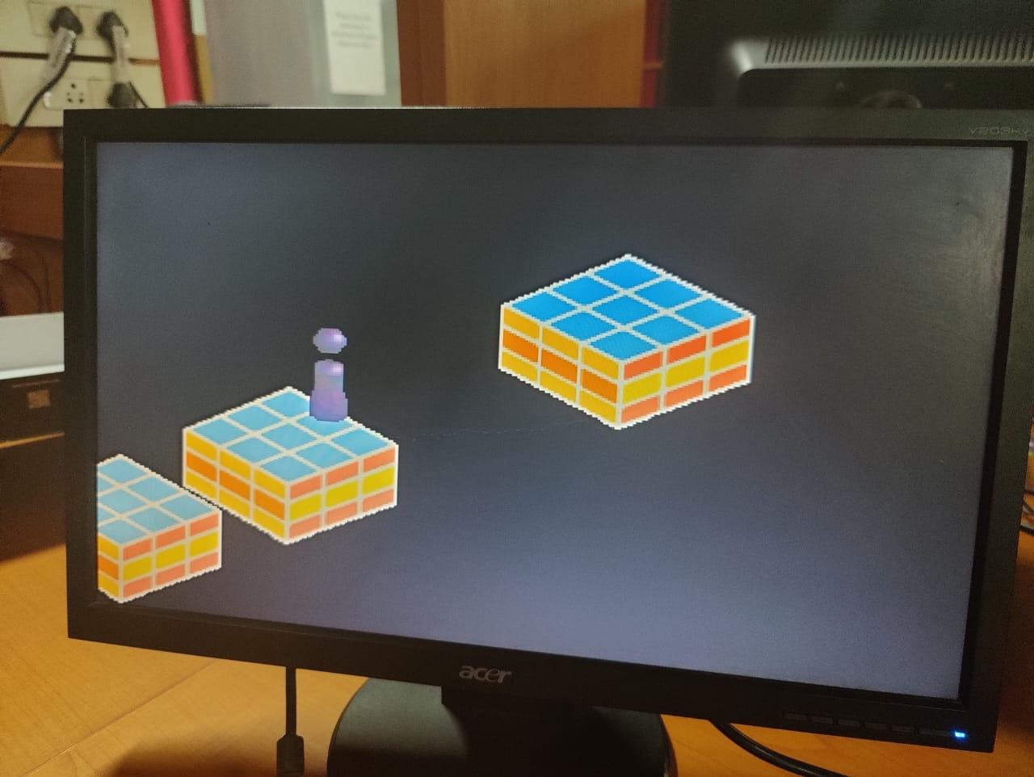

Now after jumping to the new block another block appears at a randomn distance and it repeats until you fall down. To make the object jump long distances you need to hold down the key0 for a long time and you can see the number of led lights lit up which represents the power of object to jump that distance long. Now for every successful jump the object make the screen in fpga displays the score which is the number of blocks successfully jumped over by the object.

IT is displayed as follows:

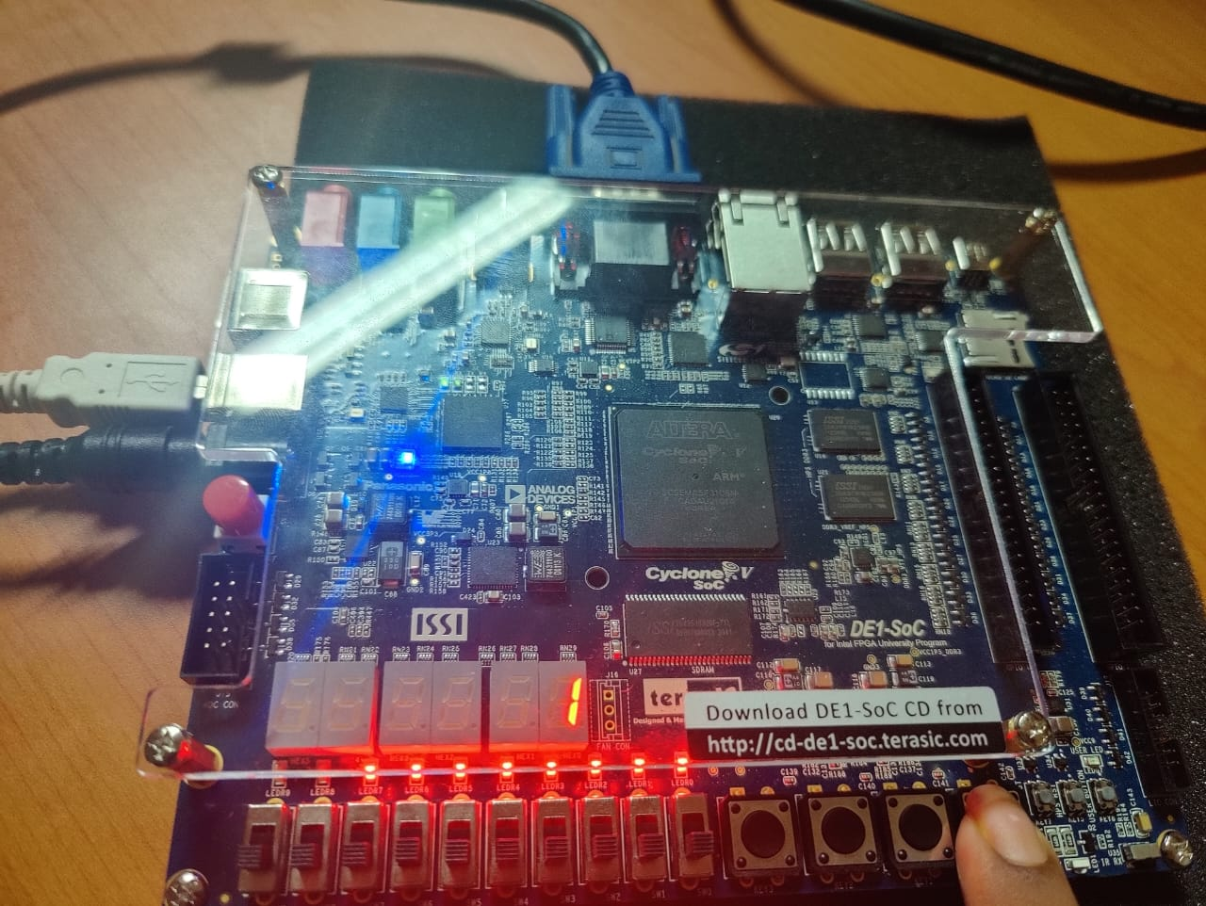

Now, if the object fails to land on a block then the game is over and you will be redirected to the home page and it displays as follows:

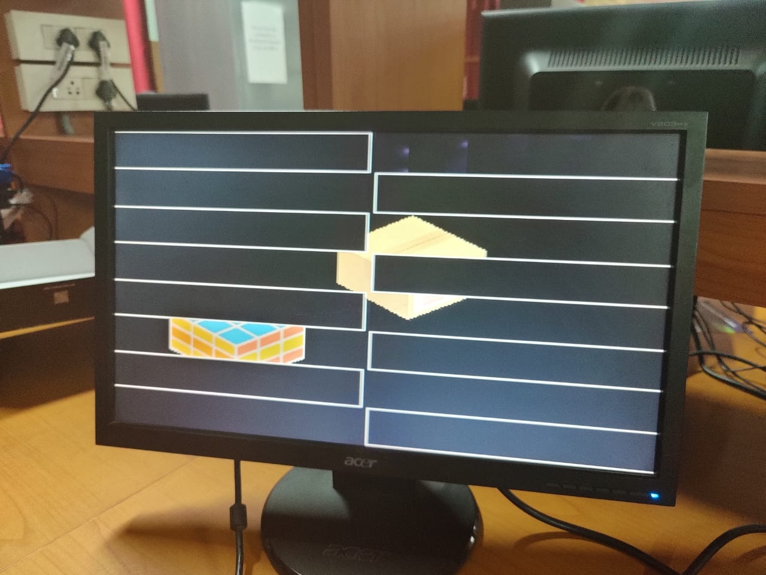

NOW in the home page you can see in the homepage it is mentioned as “the best jumping record now is” this gets updated every time the score which is scored in a new game is higher than the previous record.

Which is displayed as follows:

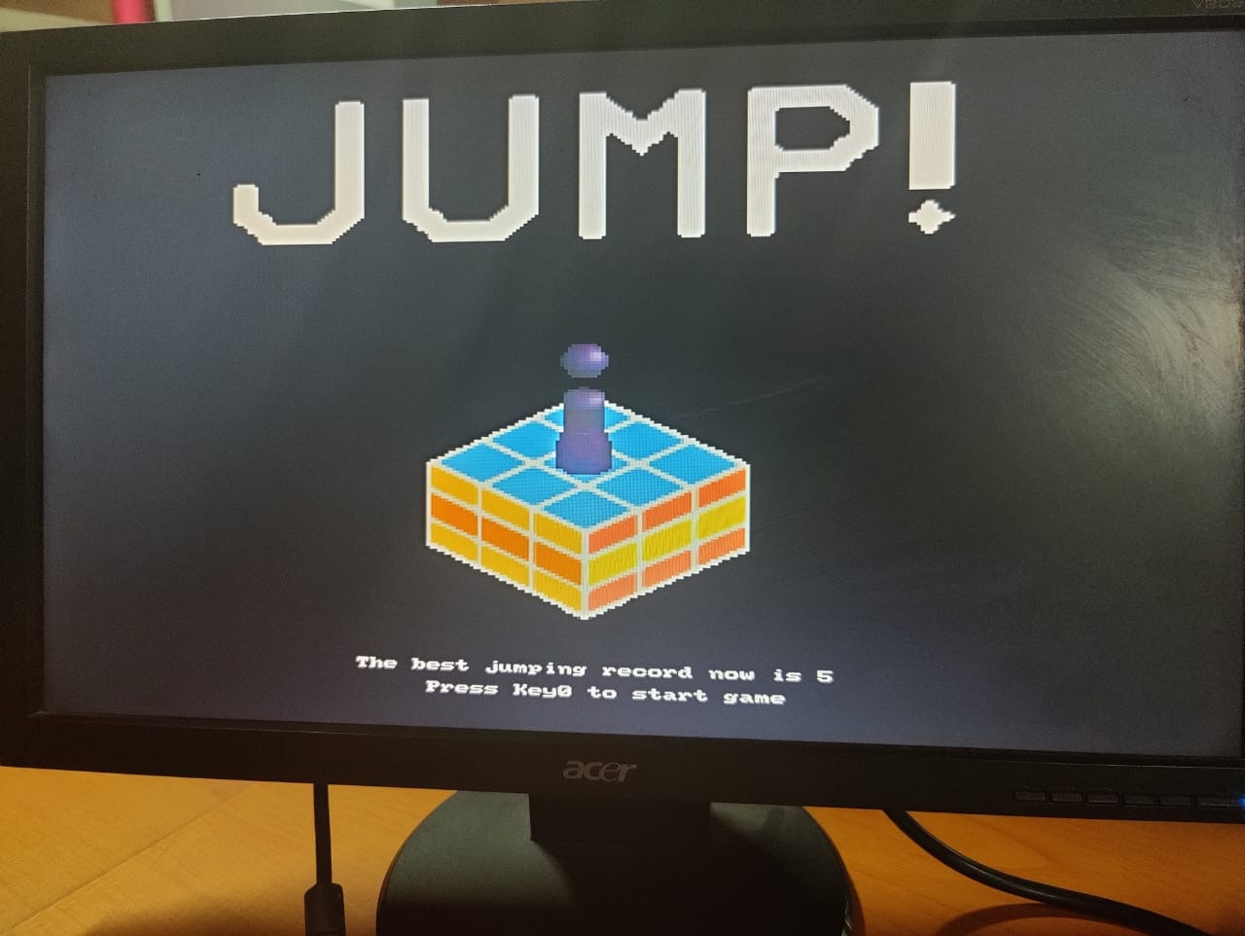

Now this high score is also updated in the terminal in computer at intel fpga application. This can be seen as:

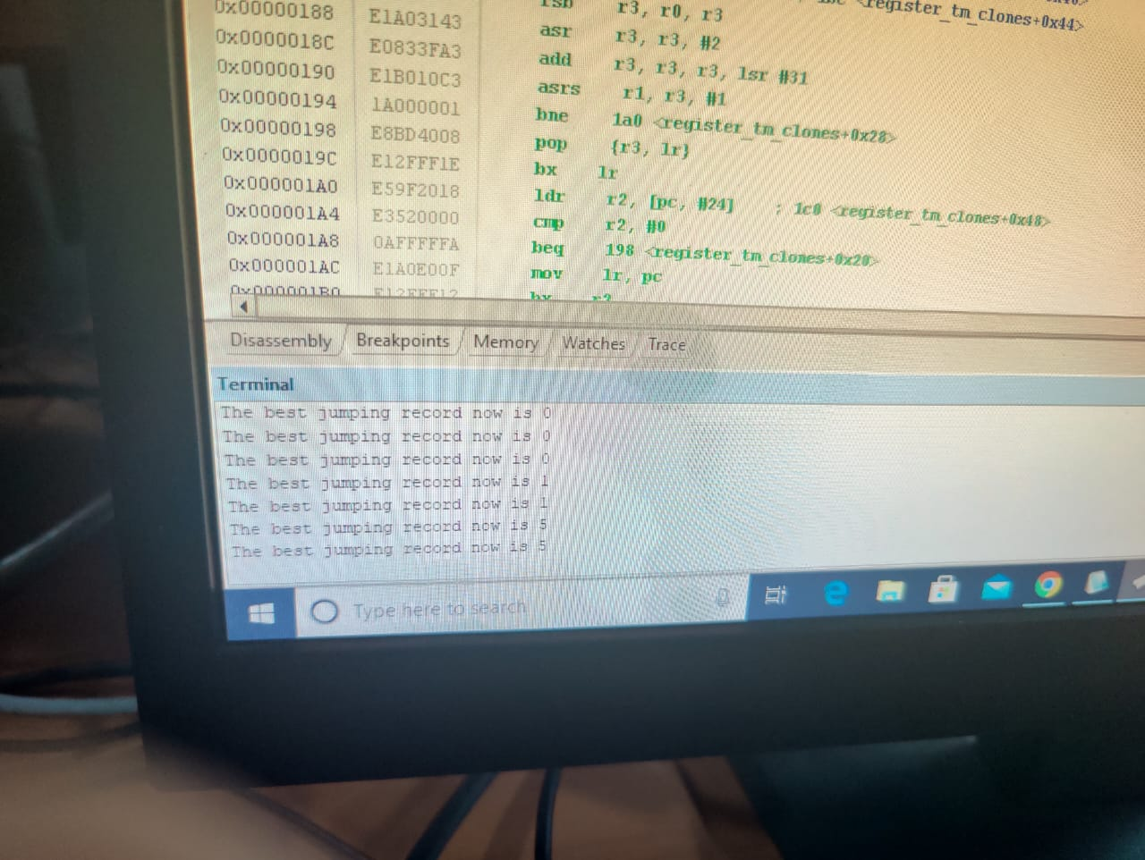

**Conclusion:**

This a simple mini project JUMP designed to show the use of fgpa and its function in creating the visual effects. In this project we have mentioned how this game JUMP works with fgpa and how the game works in a detailed way.